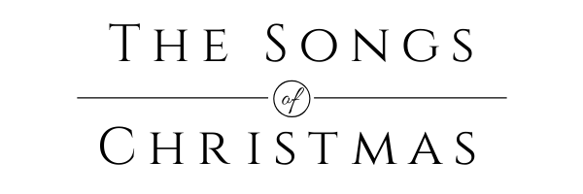

The Song to the Shepherds
Luke 2:8-20

Introduction.

I. The recipients of the Song. (vv. 8-10)

II. The message of the Song. (vv. 11-14)

III. The response to the Song. (vv. 15-20)

Conclusion.

