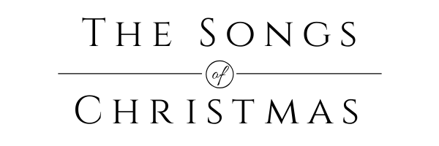
The Song of Simeon—Steadfast Waiting
Luke 2:22-38

Introduction.

BIG IDEA: We never waste our lives when we actively wait on God!

I. Mary and Joseph. (vv. 22-24)

II. Simeon. (vv. 25-35)

III. Anna. (vv. 36-38)

Conclusion.

